|  |  |
| --- | --- |
| **Homework 3**  **Due June 17 2018 at 11:30pm** | **Chapter 10 – Object Oriented Thinking**  **Chapter 11 – Inheritance and Polymorphism** |

**Objectives**

To apply class abstraction to develop software (§10.2).

To discover the relationships between classes (§10.4).

To design programs using the object-oriented paradigm (§§10.5–10.6).

To simplify programming using automatic conversion between primitive types and wrapper class types (§10.8).

To use the String class to process immutable strings (§10.10).

To define a subclass from a superclass through inheritance (§11.2).

To invoke the superclass’s constructors and methods using the super keyword (§11.3).

To override instance methods in the subclass (§11.4).

To distinguish differences between overriding and overloading

(§11.5).

To explore the toString() method in the Object class (§11.6).

To discover polymorphism and dynamic binding (§§11.7–11.8).

To store, retrieve, and manipulate objects in an ArrayList (§11.11).

To construct an array list from an array, to sort and shuffle a list, and to obtain max and min element from a list (§11.12).

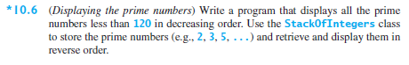

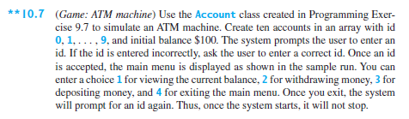

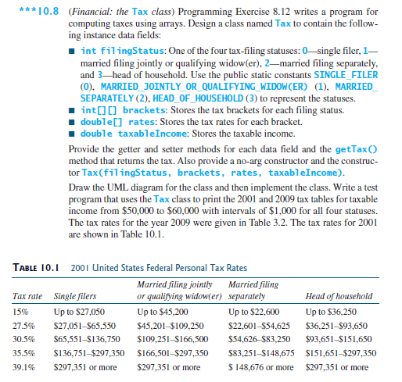

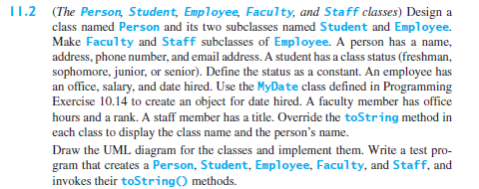

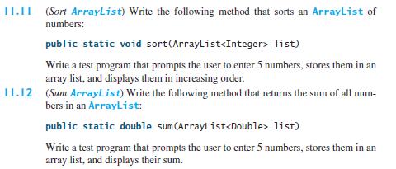

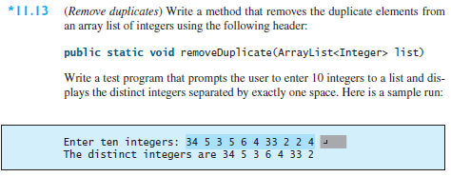

## Task List

You are required to complete the following activities by the deadlines specified and submit the appropriate *deliverables* through eLearning.

|  |  |
| --- | --- |
| Activity | Deadline |
| Create Class Files having its own main method for each of the problems in this assignment. ________________________________________________  Compile, Execute and Test your program | June 17 |
| Zip the Java Files and submit on eLearning |

## Guidelines

You will be graded according to the following guidelines:

* You are required to submit files through eLearning by the specified deadline. You can earn a maximum of 100 points.
* If the files do not compile, you will receive a 0 for the program.
* You are graded primarily on the design of your class and the adequate testing of your class. Poor design or inadequate testing will result in loss of points.
* Your files should be adequately commented. Up to -15 points will be deducted for poor indentation and documentation.